在编译的时候，出现了如下错误：

qt.network.ssl: QSslSocket : cannot call unresolved function TLSv1_1_client_method

qt.network.ssl : QSslSocket : cannot call unresolved function SSL_CTX_new

qt.network.ssl : QSslSocket : cannot call unresolved function SSL_library_init

qt.network.ssl : QSslSocket : cannot call unresolved function ERR_get_error

qt.network.ssl : QSslSocket : cannot call unresolved function ERR_get_error

安装Win32OpenSSL-1_0_1g.rar：

在安装目录，找到libeay32.dll 和 ssleay32.dll 文件：

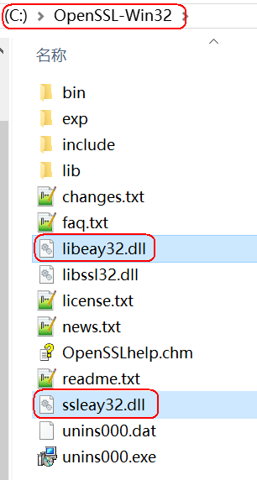

然后将libeay32.dll 和 ssleay32.dll 文件拷贝到如下的Qt目录：

